**#Python program to add lists**

**#Add using append.**

x=[2,3,4,5]

y=[-1,2,-2,1,22,1]

z=[10,20,15,30,25,67]

print("x:",x)

print("y:",y)

print("z:",z)

res=[]

for i,j,k in zip(x,y,z):

res.append(i+j+k)

print("res:",res)

**OUTPUT**

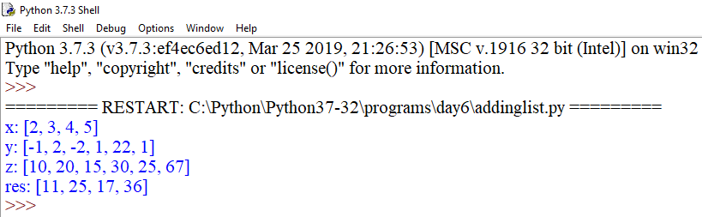

**#Add using function**

x=[1,2,3,4,5,6]

y=[10,20,30,40,50,60]

z=[11,22,33,44,55,66]

def abc(a,b,c):

return a+b+c

res=list(map(abc,x,y,z))

print(res)

**OUTPUT**

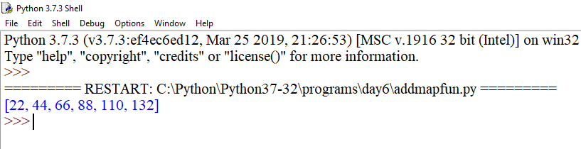

**#Add using anonymous function i.e. lambda**

x=[1,2,3,4,5,6]

y=[10,20,30,40,50,60]

z=[11,22,33,44,55,66]

res=list(map(lambda a,b,c:a+b+c,x,y,z))

print(res)

**OUTPUT**

